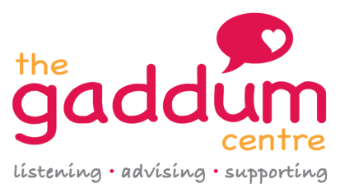
WELFARE BENEFITS AND MONEY ADVICE PROJECT REFERRAL FORM
Service User Details
Title
Forename |  | Surname
Home Address

Postcode

Telephone | Email | Mobile
Male Female Transgender |  | Date of Birth

Next of Kin/Carer/Point of Contact Details
Title
Forename | Surname | Relationship to client
Home Address

Postcode

Telephone | Email | Mobile

Preferred Method of Communication? (Please state if contacting next of kin/family/carer would be preferred). Please state if there are particular times of day to call/not call.

Any communication or language difficulties?
Is a home visit required? Yes No

Details of any risks the service needs to be aware of. Please provide details
Nature of Impairment/Disability? Please provide details

Does the service user have water debt to United Utilities? Please provide details (including any other known debts/arrears)

Reason for referral to the Welfare Benefits and Money Advice service? Please provide details

Ethnicity
White British |  | Asian British or Indian
White Irish |  | Asian British or Pakistani
White Other |  | Asian British or Bangladeshi
Mixed White and Black Caribbean |  | Black British or Black Caribbean
Mixed White and Black African |  | Black British or Black African
Mixed White and Asian |  | Other Black
Mixed White Other |  | Chinese
Other

Faith or Religion
Buddhist |  | Christian |  | Hindu |  | Jewish
Muslim |  | Sikh |  | Other |  | None

Sexual Orientation
Bisexual |  | Heterosexual/Straight |  | Lesbian/Gay
Other |  | Prefer not to say

Referrer Details
Name

Organisation/Role

Telephone

Email

Date of referral:
Please return completed form to: welfareadvice@gaddum.co.uk or fax to 0161 839 8573

